Paper Mache Sculpture

You will be thinking creatively in order to develop multiple visual ideas to solve a problem.
You will be able to represent your best idea in a 3 dimensional form.

Here are some things you will be learning in the next several weeks.
- Critical Thinking /Problem Solving
- Effective Communication
- Creativity
- Collaboration
- Flexibility /Adaptability
- Productivity /Accountability

For this you will need:
- A pencil
- A brain…
- And some creativity and resourcefulness.

Day 1:
3 Minute video clip from the movie “Speak”
Out of a hat.
Today you will choose your destiny for art making. You will choose a word and then spend the rest of class defining this word both visually and linguistically. Include EVERYTHING you know about this word. Sketch and draw a lot. Begin collecting things that relate to your word when you see them. It may be from a magazine or a wrapper you tear off a candy bar. The point is, keep your eyes open! Try to find one inspiration EVERYWHERE!!!

My word is:______________________________
“What if we settled?” Video Clip – 33 seconds.
“Get it all out” Project
Fill an 18x24 piece of paper with as many sketches of your word as possible. You should use any idea you have to fill this paper. Think, not only about what your image looks like, but does it have multiple meanings? Different ways of depicting it? THINK! THINK!! THINK!!!

Day 2:
Of all of your sketches choose the idea that will be the most successful and do-able sculpture. Think about materials you will have available and the materials you may have to provide. This won’t limit you but it will force you to be resourceful and CREATIVE!

Sketch out your plan for building with 3 views of your project, include measurements. Then fill out the calendar with a plan as to how you are going to complete your work before the end of the year. This must be done before you start your project!!!
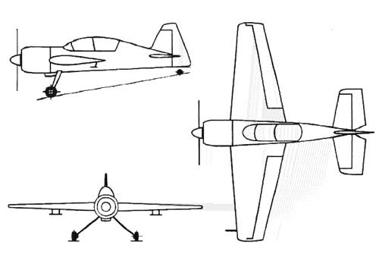

Monday | Tuesday | Wednesday | Thursday | Friday
17 | 18 | 19 | 20  Sculptures Begin | 21
24  Work on Blueprints/Plans | 25 | 26  Self-guided plan begins. | 27 | 28
May 1 | 2 | 3 | 4 | 5
8 | 9 | 10 | 11 | 12
15 | 16 | 17 | 18 | 19  Sculptures due
22  Sculptures due | 23 | 24 | 25  Clean-up Day | 26  Clean-up day  Last Day of School
29  Mrs. Ludwig’s Birthday. | 30 | 31 | June 1 | 2

